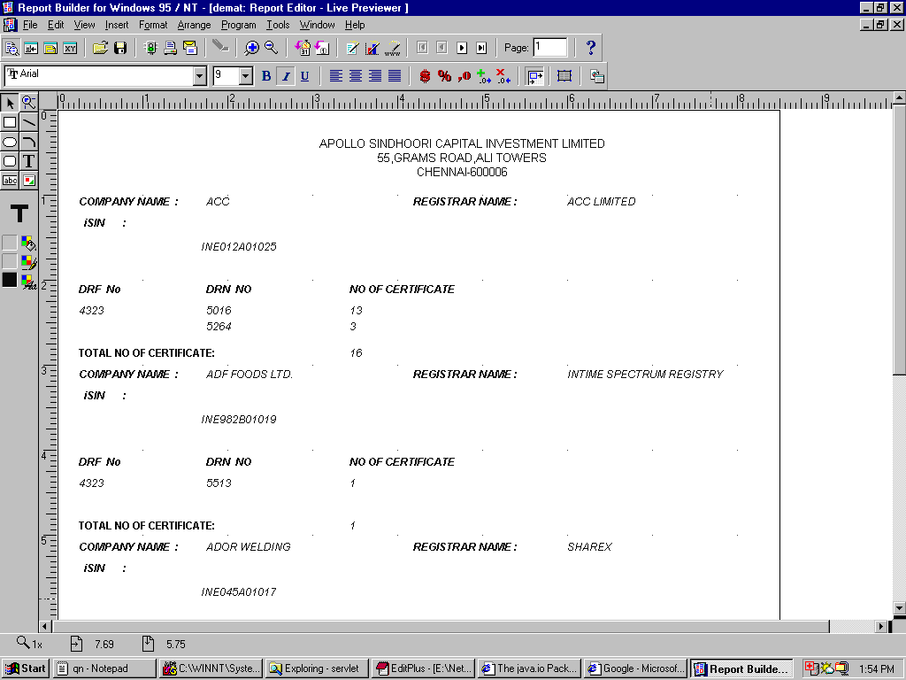

I have grouped the above record using isin field ,I want the next group(isin field) to be printed in the next page and so on. What should I do for the same?

